Hi Lakeland Harbor Residence!
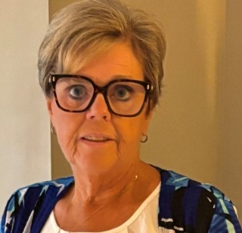
I am excited to announce my candidacy for a position on our Homeowners Association (HOA) Board. As a resident who has grown to love this community, I am deeply invested in continued growth and advancements for all residents. I am currently a Co-Chairperson for Lakeland Harbor Social Committee and along with my husband Dubby, chaired Karaoke for the past two years.

Personal Background and Professional Experience
Dubby and I have been residents here since April 2021. We relocated to Lakeland from Warrensburg, NY. A small town in the Adirondack Mountains. During this time, we have not only enjoyed the amenities and events,but have also developed strong bonds with our neighbors.
My professional background is in Medical Laboratory Science. I am currently employed as a Medical Laboratory Scientist at Lakeland Regional Health. I hold a professional license to practice medical laboratory science in New York and Florida. I am a certified member of the American Association of Bioanalysist (AAB), the American Medical Technologist (AMT) and currently a member of the Clinical Unit Based Council at Lakeland Regional Health. The majority of my 36 year career has been in clinical laboratory management. My leadership responsibilities have included: inspiring and guiding staff to meet the organizations goals and vision, collaborating with all areas of the health system to advance services, accountability for maintaining regulatory requirements and fiscal responsibility for the organizational resources.
In every thriving community, differing viewpoints and occasional disagreements are inevitable. What defines our strength, however, is our approach to resolving such conflicts. Throughout my career in laboratory management and community engagement, I have learned that professionalism, open communication, and mutual respect are essential to building consensus and moving forward together. I believe in addressing issues directly and transparently—listening to all sides, ensuring every voice is heard, and seeking fair, constructive solutions. By focusing on the collective good and maintaining a calm, solution-oriented mindset, we can address challenges without division and foster a sense of unity and trust among residents.
Why I Am Running
I am running for the HOA Board because I believe in proactive leadership and transparent decision-making. I have witnessed the challenges our community has faced—ranging from property maintenance concerns to communication gaps. At the same time, I have seen the promise and potential that exists within our community. My goal is to bring fresh ideas and an open mind to the Board, ensuring that our collective interests are protected and advanced.

My Vision for the Community
- Community Engagement: I want to inspire residents to take the opportunity participate, share feedback, and contribute ideas by engaging in activities, volunteering or joining a committee.
- Maintenance & Improvements: I will work collaboratively with fellow board members and other governing entities to prioritize the upkeep and enhancement of our common areas, landscaping, and amenities while seeking homeowner input and balancing our financial realities
- Inclusivity & Safety: Every homeowner deserves to feel welcome and safe. I will support initiatives that foster inclusivity, diversity, and safety for all residents, and accessibility to community amenities.
Thank you for your consideration and support. Together, we can build a future we can all be proud of.

