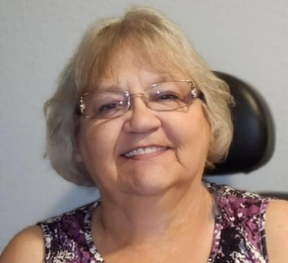
Deanna Houck

4611 Lakeland Harbor Loop • Lakeland, FL 33805
📞 863-450-0798

Board & Leadership Experience
Homeowners Association Board Member (2023–2025)
Serving as a dedicated HOA Board Director with two years of leadership experience, working collaboratively with neighbors to maintain property values, enhance community amenities, and ensure responsible management of shared resources.

Education
Master’s Degree in Educational Leadership – University of South Florida & Columbia University (2010)
Bachelor of Arts in Education (Social Science Education Concentration) – University of South Florida (1997)

Professional Highlights
Educational Advisor, Smithsonian Museum of African American History and Culture
Developed national curriculum resources for teachers, students, and homeschooling families as part of the Oh Freedom! Project.
History Grant Teams (2004–2009)
Collaborated with the National Council for History Education and the Smithsonian Institute to design instructional materials accessible to educators nationwide.

Skills & Strengths
- Collaborative decision-making and consensus building
- Clear and professional communication
- Calm, steady leadership in emergency situations
- Motivating others toward shared goals
- Strong organizational and data review skills
- As both a resident and current Board Member. I am deeply invested in the success and well-being of the Lakeland Harbor community. I have demonstrated my commitment by helping to make Board decisions that protect property values, enhance shared amenities, and ensure fairness in governance. Drawing on my background in education and leadership, I approach challenges with transparency and collaboration, ensuring every voice is heard. My goal is to continue fostering a neighborhood that is safe, welcoming, and a place all residents are proud to call home.

